
PC 317
Systems Analysis and Design
Worksheet No. 1: Project Identification and Initiation- A Business Case | Date: 26/08/26
1. Armenta, Mikka
2. Ilustrisimo, Daniel Grant
Student Names:
3. Navarro, Rey Anderson
4. Villarias, Medy

Objectives : Given the materials, tools and equipment, upon completion of the activity, the student must be able to:
1. Identify and initiate a project.
2. Present project proposal during concept hearing.
3. Secure approval of the panel.

Accomplish the following tasks:
1. Give a brief description of the client selected.
1.1 official business name
1.2 location
1.3 primary point of contact
2. Describe your client's underlying business process.
2.1 current system used (as-is system)
2.2 gap in the system
2.3 BPM
3. Identify its:
3.1 strong business needs for a system
3.2 requirements for developing the system (to-be-system)
3.3 tangible or intangible business value gained from the system
1.1 Jayraldine's Catering Services

1.2 518 V. Rama Avenue, Barangay Calamba, Cebu City
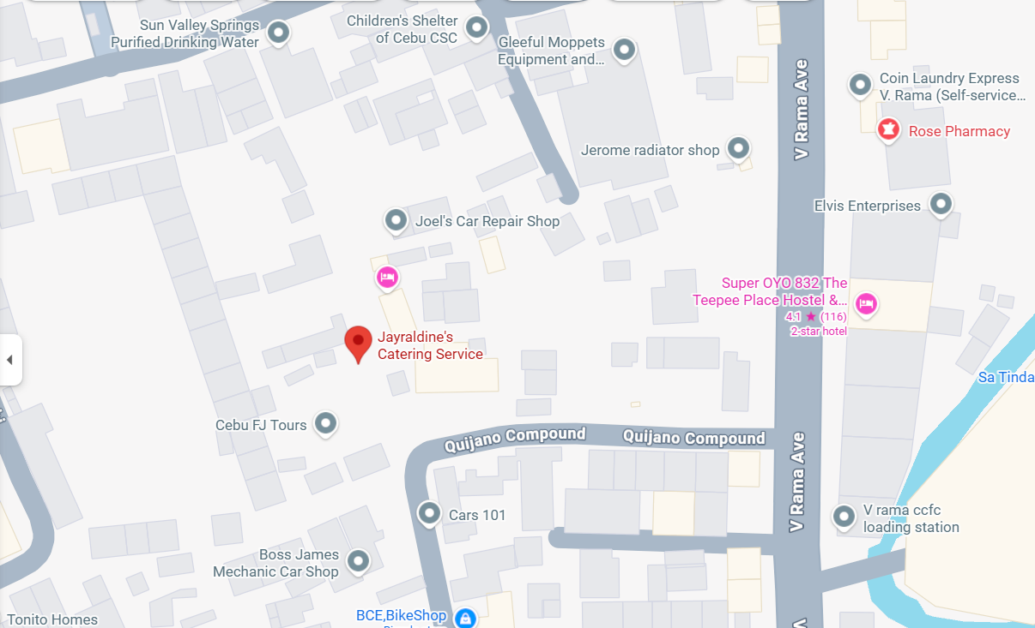

1.3 Social Media: You can message them directly on the Jayraldine's Catering Services Facebook Page.
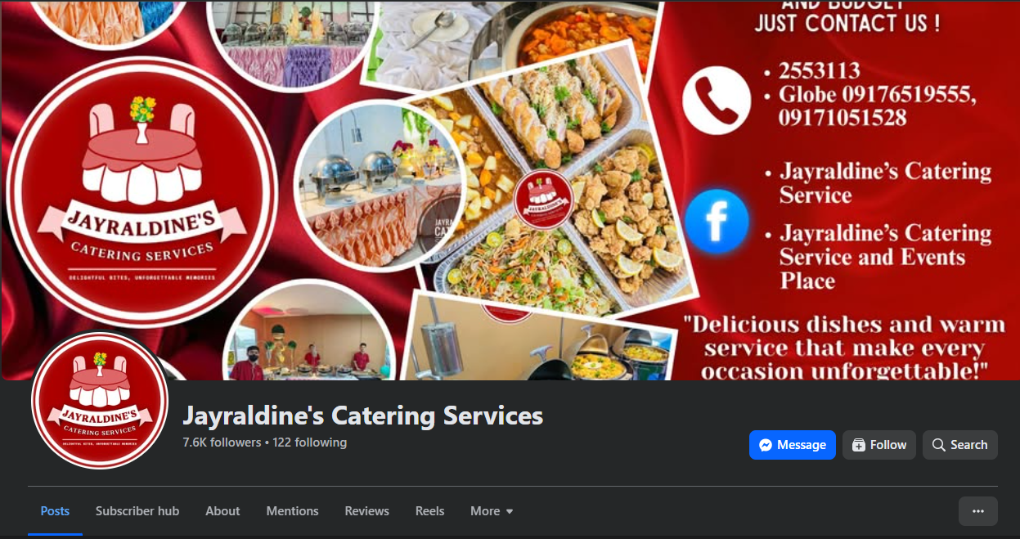
2.1 Jayraldine's Catering Services operates as an end-to-end event catering, styling, and logistics provider managing full-scale event production from client onboarding to post-event teardown. The business oversees customer consultations, customized package creation, ingredient procurement, bulk culinary preparation, and on-site event execution. All operational and administrative data—including event dates, guest tallies, package add-ons, and payment schedules—are managed manually through physical tracking forms filed inside clear book binders.

The current operational workflow is entirely paper-based and centers on a clear book binder acting as the single source of truth. The process begins during the inquiry and booking stage, where prospective clients reach out via the Jayraldine's Catering Facebook page or walk into the office. Staff manually flip through the clear book calendar to verify date availability, recording client names, contact details, guest counts, and event locations onto paper inquiry slips.
During the package customization and quotation phase, staff work directly with clients to tailor menu options and add value inclusions such as complimentary venue access, Tiffany chairs, themed backdrops, and sound systems. Total package pricing, required downpayments, and remaining balances are calculated by hand. Once agreed upon, a paper contract is drafted, signed by both parties, and placed inside a dedicated clear book sleeve.
The workflow moves into operational execution as event dates approach. Kitchen and logistics personnel manually transcribe details from the clear book onto separate ingredient checklists, prep sheets, and hauling logs. On the event day, teams deploy equipment, set up the venue styling and audio systems, prepare the buffet lines, and manage on-site food service.
The cycle concludes with billing settlement and monitoring. On-site staff compute the final balance upon delivery or event completion, collect payment, and issue manual paper receipts. Customer feedback is collected informally through verbal check-ins or unarchived Facebook Messenger chats, after which the completed contract sheet is filed into the clear book archive.
Illustration of Business Operations
The operational flow follows a sequential lifecycle that transitions through customer intake, scheduling verification, contract setup, physical logistics, and post-event settlement:
A prospective client reaches out through Facebook or an in-person visit → staff manually cross-reference the physical clear book calendar to verify schedule availability → staff negotiate customized menu choices and bundled inclusions such as venue access, Tiffany chairs, and sound systems → staff calculate costs by hand, draft a paper contract, collect the downpayment, and store the physical document in the clear book → kitchen and logistics teams transcribe event details into prep logs and delivery sheets → staff deploy to the venue to execute styling, sound setup, and buffet service → on-site staff collect the remaining balance and issue a paper receipt → completed paperwork is permanently archived into the clear book, and informal feedback is collected to wrap up the booking.

2.2 Gaps in the System

G-1: Data Redundancy and Transcription Errors Customer details, menu choices, and headcount specifications are manually re-copied across multiple paper slips, contracts, kitchen lists, and receipts, leading to conflicting records and human error.

G-2: High Vulnerability to Data Loss Physical clear books and paper forms lack automated backups and disaster recovery, leaving records susceptible to permanent loss from spills, physical damage, misplacement, or wear and tear.

G-3: Inefficient Data Retrieval and Search Bottlenecks Staff must manually flip through thick binders page-by-page to verify past bookings, locate customer history, or check availability, causing significant delays during customer inquiries.

G-4: Risk of Overlapping and Double Bookings The lack of a centralized, real-time scheduling calendar makes tracking concurrent events difficult, creating operational blind spots and increasing the risk of scheduling conflicts.

G-5: Inconsistent Billing and Payment Tracking Manually calculating package costs, add-ons, downpayments, and final balances on paper creates billing discrepancies and makes tracking outstanding balances difficult.

G-6: Operational Miscommunication Across Teams Because records are confined to a single physical clear book, front-desk staff, kitchen crews, and on-site logistics teams cannot access live updates simultaneously, leading to coordination breakdowns.

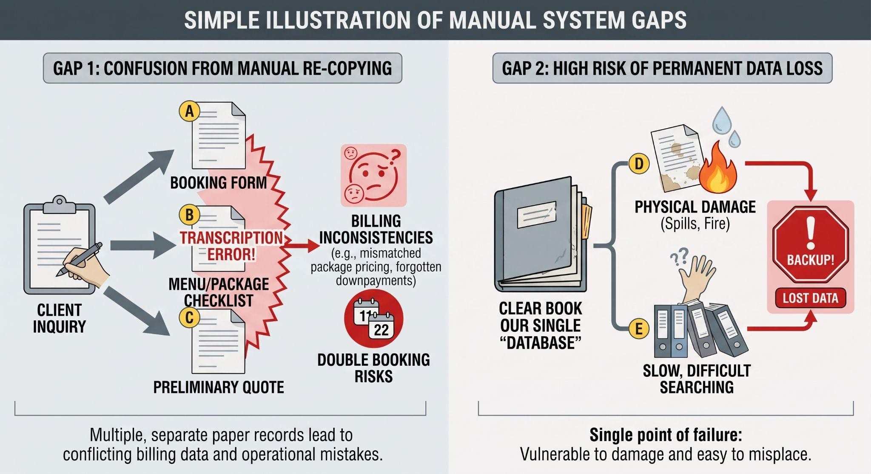

2.3 Business Process Management (BPM) in Jayraldine's Catering Services
- Business Process Automation (BPA) BPA focuses on replacing repetitive, manual tasks with automated digital functions without overhauling the core workflow. In Jayraldine’s Catering, this involves automating total cost calculations, package add-on pricing (e.g., Tiffany chairs, backdrops, sound systems), digital invoice generation, and recording payment downpayments automatically instead of writing and calculating them by hand on paper slips.

- Business Process Improvement (BPI) BPI refines and streamlines existing procedures to eliminate bottlenecks, reduce cycle time, and prevent errors. For the business, this means implementing a centralized digital schedule to instantly verify date availability, removing the need to manually flip through clear book binders. It also syncs booking details directly with kitchen prep and logistics lists, eliminating manual re-transcription and preventing communication gaps between front-desk staff and service crews.

- Business Process Reengineering (BPR) BPR completely transforms and redesigns the operational model from a decentralized, paper-dependent system into an integrated digital catering management system. Instead of relying on isolated clear books, hand-written contracts, and verbal updates, the entire lifecycle from customer inquiry and custom quote generation to automated inventory allocation, event tracking, and digital archiving is unified into a single database platform, fundamentally transforming how Jayraldine's manages events.

3.1 strong business needs for a system

*Title- Propose System
Jayraldine’s Catering Services has critical business needs centered on data security, operational efficiency, data accuracy, and financial visibility that necessitate a transition away from its paper-based clear book workflow. To address high vulnerability to permanent data loss from physical wear, spills, or misplacement, the business requires a secure digital repository equipped with automated backups for long-term disaster recovery. Operationally, replacing manual filing with a centralized platform eliminates severe search bottlenecks, allowing staff to verify schedule availability instantly and apply real-time updates to booking changes without operational delays. Furthermore, a digitized system resolves persistent issues with data accuracy and consistency by replacing handwritten records with structured entries, effectively mitigating human error, preventing duplicate or overlapping bookings, and eliminating miscommunication with the kitchen crew. Finally, establishing digital financial tracking provides the management with real-time financial visibility to monitor customer payments, track outstanding balances, calculate net profit margins, and analyze historical financial performance with precision.

3.2 Requirements for Developing the Proposed System

- F1 - Order Management & Booking System: Captures and tracks all catering inquiries, event bookings, guest headcounts, and package specifications.
  - F1.1 - Inquiry & Reservation Tracker: Records prospective customer information, preferred event dates, venue locations, and booking statuses (e.g., Pending, Confirmed, Completed, Cancelled).

  - F1.2 - Package & Menu Selector: Configures standardized food packages, custom menu requests, and special dietary notes per booking.

- F2 - Billing & Payment System: Generates itemized client invoices, tracks payments, handles billing updates, and records add-on charges.
  - F2.1 - Automated Cost & Add-on Calculator: Automatically computes totals based on headcount, tier packages, and equipment add-ons (such as Tiffany chairs, themed backdrops, and sound systems).

  - F2.2 - Payment & Receipt Generator: Logs downpayments, tracks remaining balance due dates, and produces printable, official billing receipts.

- F3 - Printable Event Calendar System: A centralized digital schedule to manage availability, display full event details, and print formatted schedule overviews for staff and kitchen execution.
  - F3.1 - Visual Schedule & Conflict Checker: Provides a calendar-based interface to prevent double bookings and display daily, weekly, or monthly event loads.

  - F3.2 - Printable Operational Worksheets: Generates exportable, printable summary sheets for kitchen preparation teams and logistics setup crews.

- F4 - Financial Analytics & Overview: A feature that processes billing records to deliver instant summaries of total revenue, operating costs, and profit trends.

  - F4.1 - Revenue & Expense Monitoring: Computes gross sales, collected deposits, and pending accounts receivable in real time.

  - F4.2 - Financial Performance Summaries: Generates automated profit-and-loss overviews to evaluate profitability across different package tiers.

- F5 - Customer Records & Loyalty Management: A module to track past client history, manage loyalty rewards, and incentivize repeat bookings.
  - F5.1 - Centralized Client Repository: Maintains complete contact records, previous event histories, and customer preferences.

  - F5.2 - Repeat Client & Promotion Tracker: Identifies returning clients to apply custom discounts, bundled promotions, or loyalty incentives.

- F6 - Dashboard & Comparative Reporting: A comprehensive reporting tool that visualizes billing data and conducts month-over-month and year-over-year performance comparisons to track business growth and support strategic decision-making.
  - F6.1 - Executive Overview Dashboard: Displays key performance indicators (KPIs), including active monthly bookings, top-selling packages, and total receivables.

  - F6.2 - Historical Comparative Reports: Generates comparative charts and exportable reports showing revenue trends, seasonal peak periods, and yearly booking growth.

3.3 Tangible and Intangible Business Value Gained from the System

Tangible Value (Measurable Financial & Resource Impacts)

- V-1: Reduced Administrative and Material Costs (Addresses: G-2, G-3 | Enabled by: F1, F2)
Drastically cuts down expenditures on paper supplies, physical clear books, printing, and administrative labor hours by replacing manual data transcription with automated digital records.

- V-2: Increased Booking Capacity and Throughput (Addresses: G-4, G-6 | Enabled by: F1, F3)
Automated scheduling and conflict checking eliminate double-booking risks and reduce booking turnaround times, allowing the business to accommodate and manage more concurrent events effectively.

- V-3: Higher Revenue Retention and Billing Accuracy (Addresses: G-1, G-5 | Enabled by: F2, F4)
Automated calculation prevents pricing discrepancies, ensures all package add-ons (e.g., Tiffany chairs, backdrops, sound systems) are billed accurately, and eliminates lost income from uncollected final balances.

Intangible Value (Qualitative Operational & Strategic Improvements)

- V-4: Enhanced Customer Trust and Brand Image (Addresses: G-1, G-3 | Enabled by: F1, F2, F5)
Professional itemized digital invoices, faster inquiry response times, and reliable booking records elevate the business reputation and customer satisfaction.

- V-5: Operational Peace of Mind and Data Security (Addresses: G-2 | Enabled by: F1, F3)
Migrating to a centralized, backed-up database removes the persistent risk and anxiety of physical document destruction, water/kitchen spills, or misfiled clear books.

- V-6: Smarter Strategic and Data-Driven Decision-Making (Addresses: G-3, G-5 | Enabled by: F4, F6)
Immediate access to performance dashboards and comparative sales reports empowers management to make proactive decisions regarding pricing adjustments, inventory allocation, and marketing strategies.

